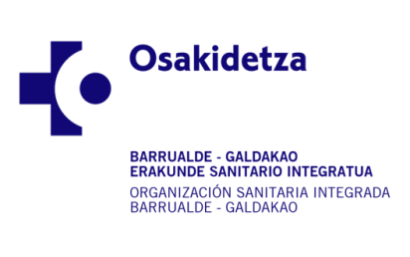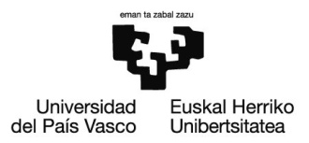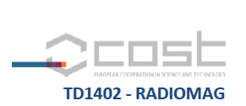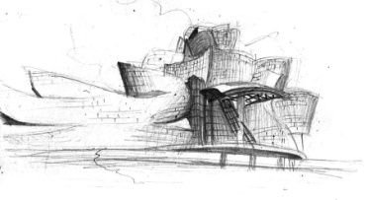

**RADIOMAG CONFERENCE REGISTRATION FORM MD**

Name: 

First Surname: 

Second Surname: 

Email: 

Degree:   M.D.  Ph.D.  Both  Staff  MIR

Work center: 

Mailing address: 

ZIP code:

Country: 

**The inscription and the access to the Thursday morning session (Building bridges with Interventional Oncology) is free, but it does not include the coffee served during the coffee-break.**