Curriculum Vitae - Lucas Polo Fonseca
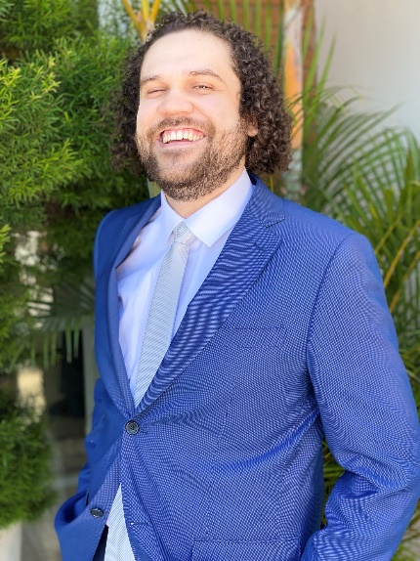
PERSONAL DATA
Name: Lucas Polo da Fonseca
e-mail: lucas.polodafonseca@ehu.eus
Adress: POLYMAT, University of the Basque Country UPV/EHU, Joxe Mari Korta Center, Avda Tolosa 72, 20018 Donostia-San Sebastian, Spain.
Tel.: +34 674864668
Birthday: 04.10.1994 in Campinas – SP, Brazil
Marital Status: Maried
ACADEMIC QUALIFICATIONS
- 08.01.2017 – 10.01.2021: Ph.D. of chemistry at the University of Campinas (UNICAMP).
- 01.03.2012 – 07.01.2017: Bachelor’s degree in chemistry at the University of Campinas (UNICAMP).
- 01.02.2010 – 12/2011 Technician in Chemistry by Technical State School Conselheiro Antonio Prado, (ETECAP) (Campinas, Brazil).
- 01.02.2009 – 12/2011: High School at Technical State School Conselheiro Antonio Prado, (ETECAP) (Campinas, Brazil).

RESEARCH ACTIVITIES
01.24.2022 – today: Postdoctoral researcher in the group of professor Dr. Haritz Sardon at POLYMAT, University of the Basque Country UPV/EHU.
08.01.2017 – 10.01.2021: Ph.D. of chemistry with a scholarship of CAPES.
Title: Dynamic urea bond-mediated polymerization and its applications. University of Campinas (UNICAMP), Advisor: professor Maria Isabel Felisberti.
01.03.2017 – 03.21.2017: Winter research project.
Title: Photoactive Polystyrene Nanoparticles Size Control.
Charles University (CZ, Prague), Advisor: professor Jiří Mosinger.
01.01.2013 – 08.01.2017: Undergraduate research with a scholarship of PIBIC – CNPq.
Title: Responsive polyurethane hydrogels and their applications. University of Campinas (UNICAMP), Advisor: professor Maria Isabel Felisberti.
01.01.2012 – 05/2012 Summer Research project.
Title: Development of anti-corrosive inks based on Eco-resinas IQX
IQX-Inove Qualyx, Advisor: Dr. Silmara Neves.
CONGRESS AND SYMPOSIUMS

Several national and international conferences were attended and poster/oral presentations were performed from 2014 to 2023. The most recent ones are:
- Oral presentation entitled “Hindered ureas as precursors for polyurethanes” on the XV Brazilian Polymer Congress held in Bento Gonçalves, RS - Brazil, from 27 to 31 October 2019.
- Poster presentation entitled “Dynamic urea bond mediated polymerization as a synthetic route for linear and telechelic polyurethanes” on the European Polymer Congress held at Heraklion Crete-Greece, from 9 to 14 June 2019.
- Poster presentation entitled “Drug release and hydrolytic degradation of amphiphilic polyurethane hydrogels” on the XIV Brazilian Polymer Congress held in Águas de Lindóia, SP – Brazil, from 22 to 26 October 2017.

AWARDS

Top 5 undergraduate research awarded at the XI Week of Pharmaceutical Sciences of the University of Campinas (Unicamp), 2016, Campinas, SP – Brazil.

PROFESSIONAL EXPERIENCE AND COMMUNITY WORK:

- Synthesis of polyurethanes, synthesis of polyol-polyester polymers, dynamic urea bond mediated polymerization, synthesis of polyureas, polymeric composites, hydrogels, nanogels.

- Polymer chemistry, colloid and interface science.

- Experience in infra-red spectroscopy (FTIR), ¹H and ¹³C nuclear magnetic resonance (NMR) including diffusion ordered NMR spectroscopy (DOSY), differential scanning calorimetry (DSC), thermogravimetric analysis (TGA), size exclusion chromatography (SEC), thermomechanical analysis (TMA), dynamic mechanical analysis (DMA), X-ray diffraction (DRX), light scattering (DLS, SLS), cell viability assays, mechanical assays, kinetic modeling and simulation through Julia® language, etc.

- A research period abroad was planned during my Ph.D. studies but was canceled due to the COVID-19 pandemic.

- 08/2015 – 08/2019: Volunteer Professor of Chemistry at the Dandara dos Palmares preparatory school for teenagers under vulnerable financial conditions.

HOBBIES AND INTERESTS

Play electric and acoustic guitar, sing, read history books and romance novels.

LANGUAGES
- Portuguese: Native language
- English: Fluent
LINKS
Google Scholar: https://scholar.google.com/citations?user=oSY5HyoAAAAJ&hl=en
5 SELECTED PUBLICATIONS
Polo Fonseca L., Duval A., Luna E., Ximenis M., De Meester S., Avérous L., Sardon H.; Reducing the carbon footprint of polyurethanes by chemical and biological depolymerization: Fact or fiction?, Current Opinion in Green and Sustainable Chemistry, 41, 100802 (2023) https://doi.org/10.1002/macp.202200129

Polo Fonseca L., From nano to the macro: tuning hierarchical aggregation of thermoresponsive PEG/PCL-based polyurethanes via molar mass/composition control, Macromolecular Research, 31, 285-297 (2023) https://doi.org/10.1002/macp.202200129

Polo Fonseca L., Dynamic Urea Bond-Mediated Polymerization for Solvent-Free Low-Ð Linear Polyurethanes of Controlled Molar Mass: Hypothesis of Diffusion Control, Macromolecular Chemistry and Physics, 223, 2200129 (2022) https://doi.org/10.1002/macp.202200129

Polo Fonseca L., Zanata D. M., Gauche C., Felisberti M. I., A one-pot, solvent-free and controlled synthetic route for thermoresponsive hyperbranched polyurethanes, Polymer Chemistry, 11, 6295 (2020) https://doi.org/10.1039/D0PY01026J

Polo Fonseca L., Felisberti M. I., Dynamic urea bond mediated polymerization as a synthetic route for low molar mass dispersity telechelic polyurethanes and its block copolymers, European Polymer Journal, 118, 213-221 (2019) https://doi.org/10.1016/j.eurpolymj.2019.05.052

PATENT APPLICATIONS

Polo Fonseca, L.; Felisberti, M. I.; Process for obtaining polyurethanes: Polyurethanes with low molar mass dispersity, controlled molar mass and architecture, and their applications; National Institute of Industrial Property (INPI), Brazil, BR 10 2020 010991 0 (2020).

