Extended abstract: These instructions give you guidelines for submitting your extended abstract for the EMAN Conference 2022 in Donostia/San Sebastian. Use this document as a template if you are using Microsoft Word 2003 or later. Otherwise, use this document as an instruction set. Define all symbols used in the paper. Do not cite references in this paragraph / abstract text.
Submission Title
Author, A.; Author, B. and Author, C.
Institution name, Postcode City, Country
E-mail: corresponding.author@email.comt

INTRODUCTION
This document is a template for Microsoft Word versions 2003 or later.

Abstract
Your extended abstract should be between 5,000 and 10,000 characters long. It should contain the title of the extended abstract, the authors and their affiliation, a short abstract summary, the main contents, and a list of references. The extended abstract must be sent to the e-mail address eman2022@ehu.eus
Please submit a word document.

Main Dates
Please submit your extended abstract by 1st of June 2022. By submitting your extended abstract, you agree to its publication in the proceedings. All extended abstracts will be made accessible to conference delegates ahead of the conference.

Font Format
The text should be typed in Times New Roman font on A4 sheets, single spacing, two-column format. Margins are 25mm above, 15mm below and 20mm on the right and on the left.

Equation format
Equations are referred by their number (1), and are aligned to centre. Equation 1 is an example of equation.

(1)

Table and Figure format
Table 1 is an example of table and summarizes the used font sizes. Figure 1 is an example of figure. Tables and Figures should be numbered 1, 2, 3 and so forth. Their titles should be aligned to centre.
TABLE 1: Font Sizes

Title | 18pt | bold
Authors | 12pt | normal
Affiliation | 10pt | normal
Abstract, Keywords | 9pt | bold
Text | 10pt | normal
References | 8p | normal
Table Caption | 8pt | capitalize
Figure Caption | 8pt | capitalize
Section Heading | 10pt | capitalize
Subsection Heading | 10pt | italic

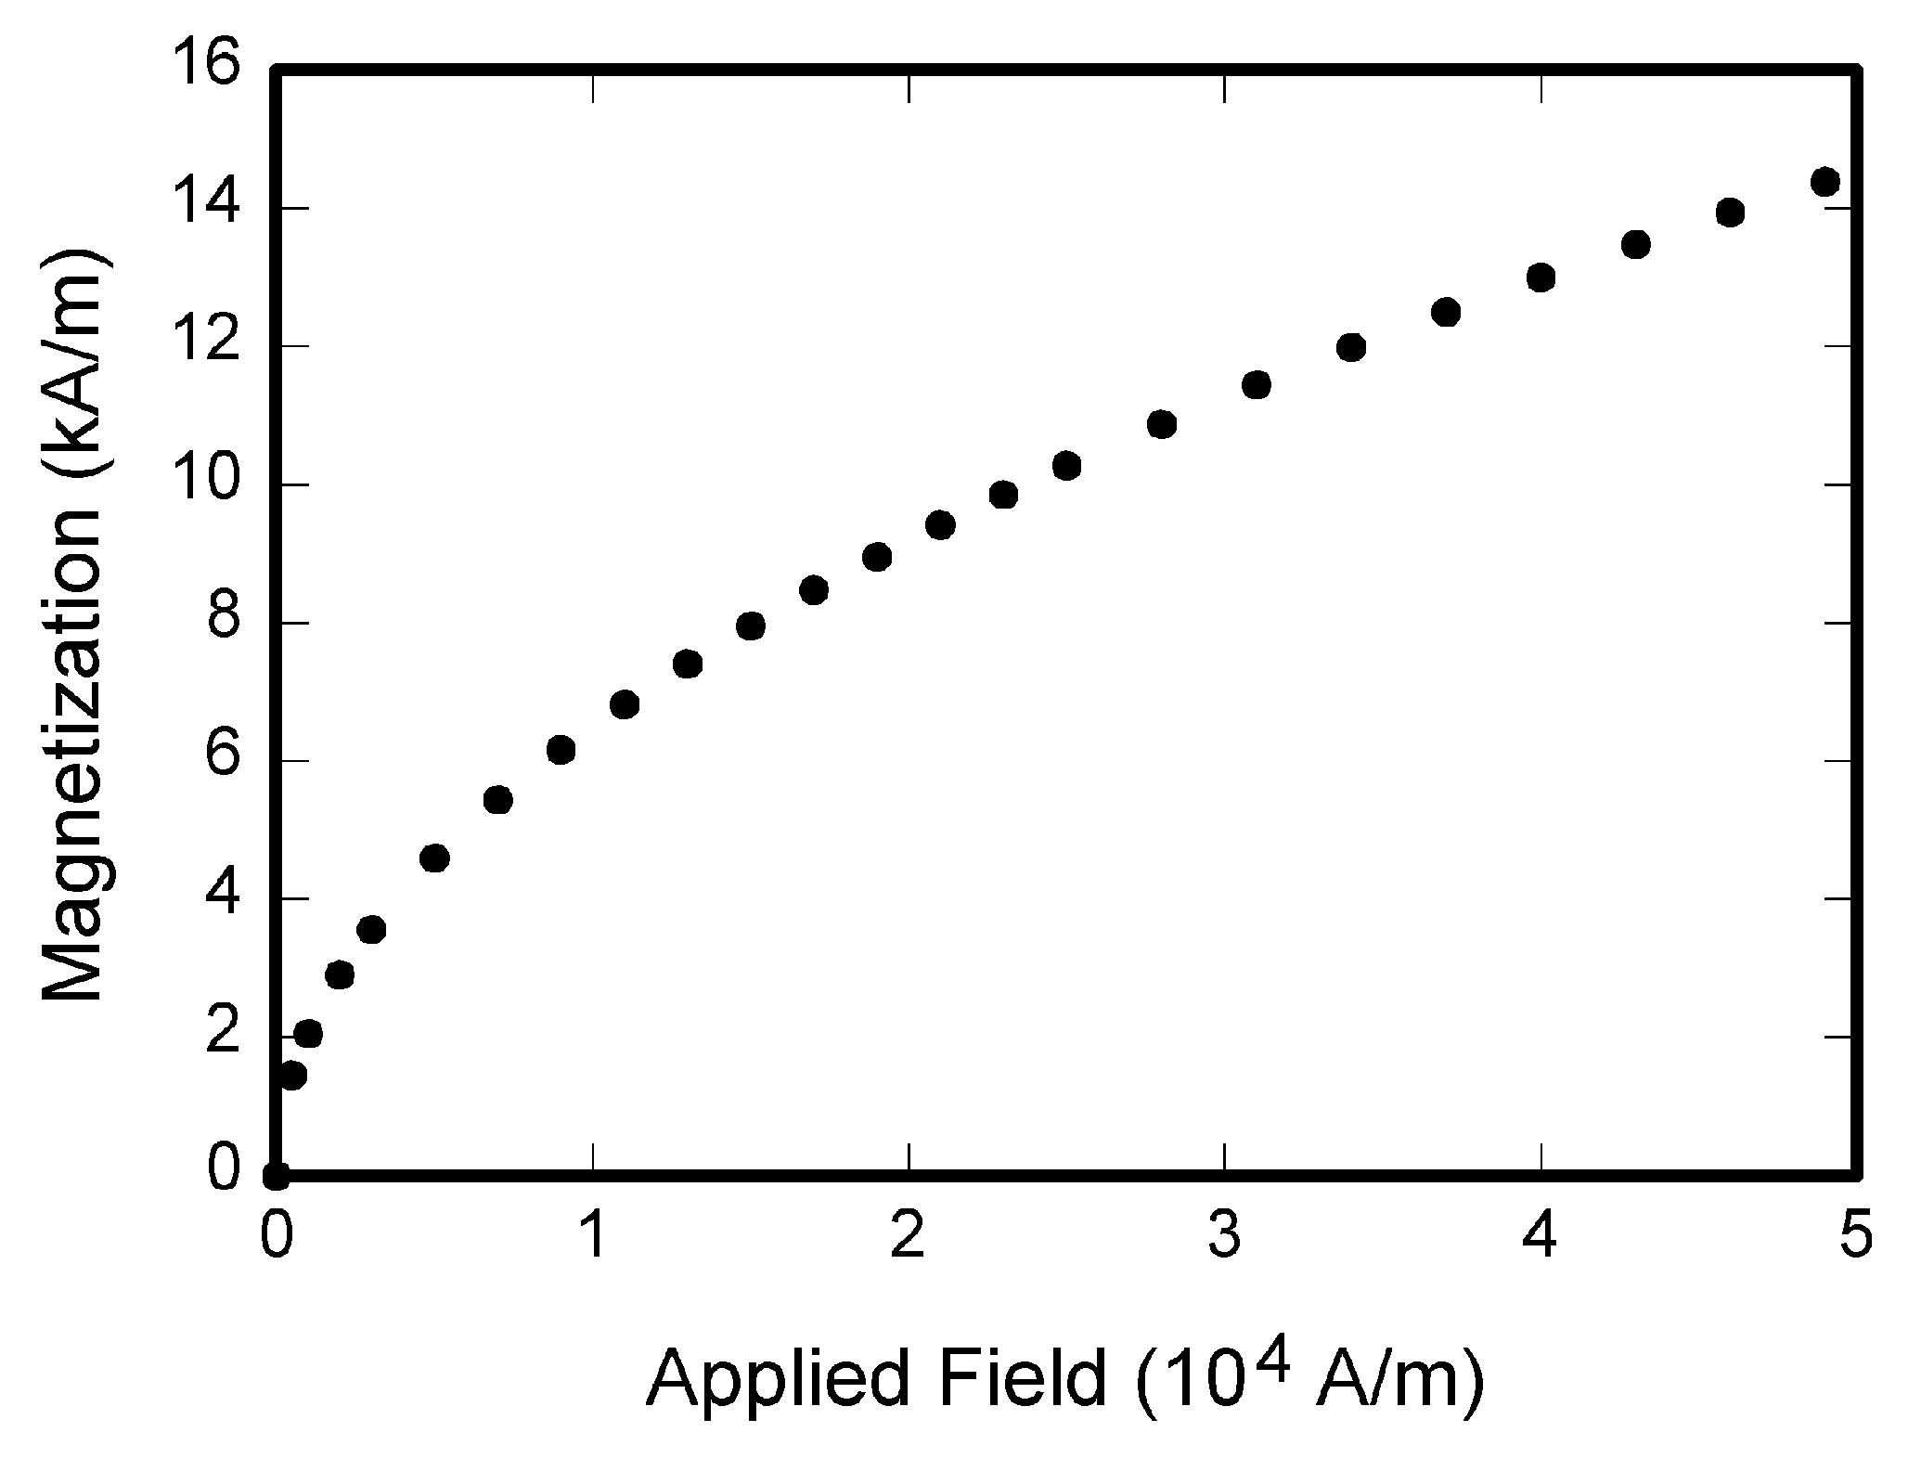
Figure 1: Magnetization as a function of applied field.

Reference format
Number citations should be marked consecutively in square brackets [1]. The sentence punctuation follows the brackets [2]. Multiple references are each numbered with separate brackets [1]-[3], [4].

Conclusion
Please use this template for your extended abstract. The extended abstract must be sent to the e-mail address eman2022@ehu.eus. If you have any questions, please do not hesitate to contact the conference organisers (eman2022@ehu.eus).
References
[Please reference journal articles like this:]
- Mueller, B.; Noble, X. & Sneddon, K. (2015): On certain integrals of sustainability functions, British Accounting Review, Vol. 47, No. 2, 529-551.
[Please reference books like this:]
- Maxwell, R. (2014): A Treatise on Electricity and Magnetism, Oxford: John Wiley Publ.
[Please reference contributions to edited volumes like this.]
- Jacobs, G. & Bean, T. (2012): Fine particles, thin films and exchange anisotropy, in: Snowden, G. & Summer, X. (eds.): Magnetism, Cambridge: Cambridge University Press, 271-350.
- Zeus, E. (2015, unpublished), Title of paper, unpublished.
- Nicole, R. (2015, submitted): Title of paper with only first word capitalized, Journal Name, submitted for publication.

