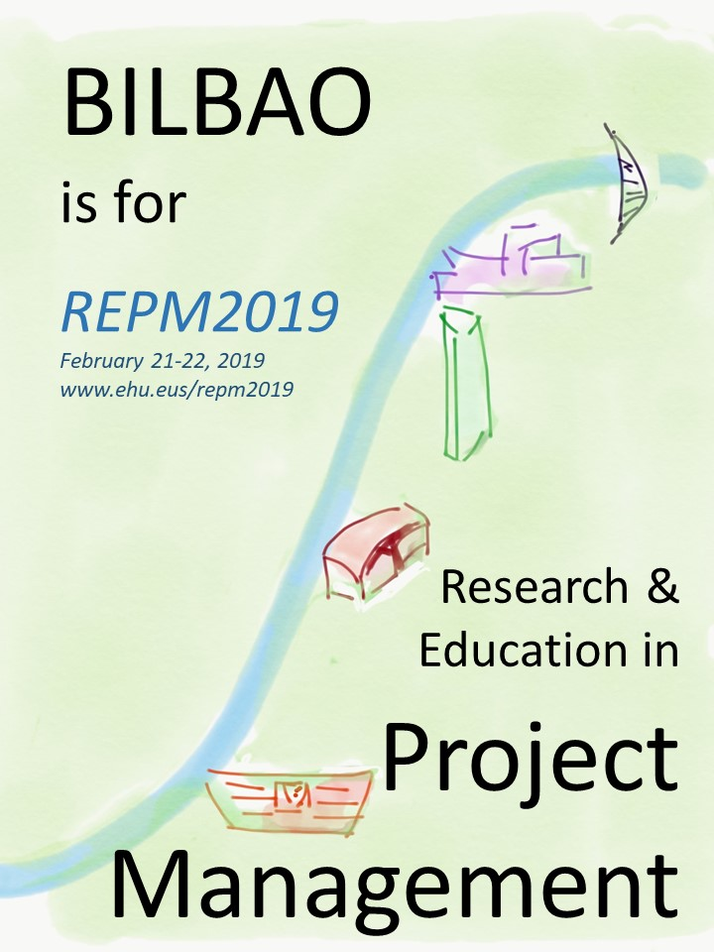
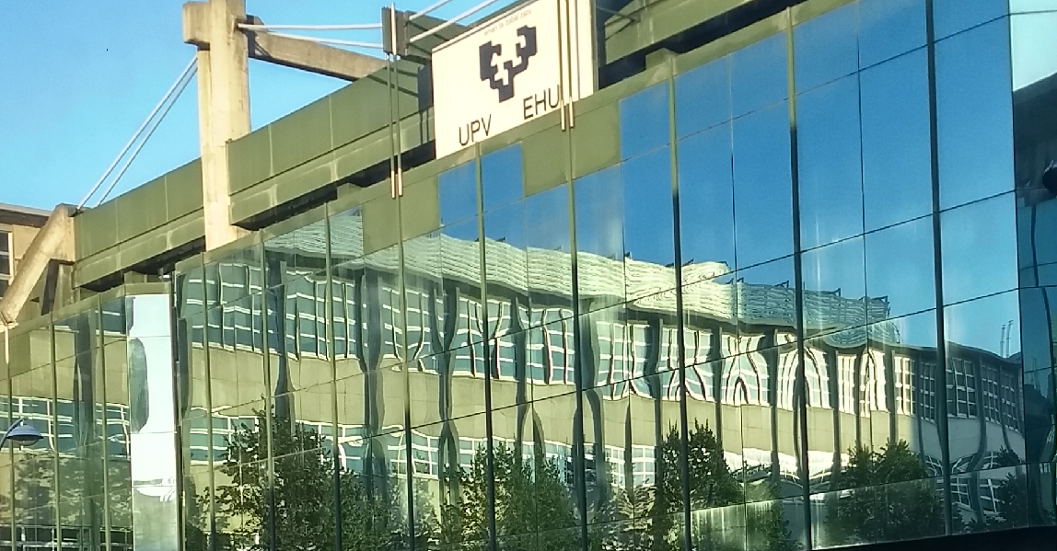
Research and Education in Project Management - REPM 2019
About the conference
Project Management is recognized as one of the best tools to develop successful developments. The objective of this Conference is to present results from advanced research into the Project management discipline.
We expect contributions from researchers, professors and doctorate and master program students. Participation of PM practitioners is expected also in workshops and seminars.
Topics
The second edition of the conference will maintain its three thematic areas: Research in PM, Sustainability and PM, and Education in PM. Besides a special slot will be dedicated to Smart Cities.
Research in PM: Continuous effort into research is the only guarantee to develop advanced techniques and tools. The PM community is being increasingly recognized through their Scientific Journals. Some of the topics to be discussed are: Methodologies for research of application in Project Management. Trends in PM and PM research. Networking as a tool for research.
Sustainability and PM: The World needs PMs to be aware of the importance of their role into sustainable development projects. Proposed topics to be discussed are: Influence of sustainability concern on Project Management practice and standards. Importance of PM for efficient Sustainable development.
Education in PM: Project Management professionals feel the need of deepening in their knowledge when they face daily problems. On the other hand, University is the main instrument to educate professionals. Cooperation between academy and industry is a must. Proposed topics to be discussed are: Life long PM education. Higher Education. Doctorate studies and PhD thesis in PM.
Smart Cities. Projects are the instruments with which cities will become smarter. The management of and for stakeholders will undoubtedly be in the core of any development project.
Important dates
Full contributions: 31 December 2018
Contact information:
repm2019@ehu.eus
www.ehu.eus/repm2019

Draft Agenda
Thursday, February 21st
8:30 | Registration
9:00 | SEMINAR. PM introduction for beginners.  Carsten Wolff. Fh Dortmund
10:00 | Opening and Keynote speeches  IPMA. Expanding world of Project Management  Jesús Martínez Almela. International Project Management Association  Utilities serve the citizen. Project Management serve the utilities  Juan Ramón Arraibi. CEO of Nortegas
11:00 | Coffee break
11:30 | Research in PM  Emerging topics in Project Management Research  Martina Huemann. Editor of ‘International Project Management Journal’  Presentations of three selected papers
12:45 | Education in PM  Responsible Project Management in the age of Climate Change  Tom Taylor. Buro four. Former APM president (Association of Project Managers in UK)  Competence based Project Management certification  Salvador Capuz. President of AEIPRO  Presentations of three selected papers
14:00 | Lunch break
15:00 | Round table. Digital Competences for Project Managers  Moderated by José Ramón Otegi (UPV/EHU-Tech4PM)  Jesús Martínez-Almela. International Project Managers Association IPMA  Salvador Capuz. AEIPRO President. Professor at U. Politècnica de València  Carsten Wolff. Fachhochschule Dortmund. EUROMPM Dortmund
16:30 | Visit to a local project: “The Manhattan of Bilbao”
20:00 | Social event. Dinner in a Txoko (Traditional Gastronomical Society)
Friday, February 22nd
9:00 | SEMINAR. Tools to manage the agile projects  Christian Reimann. Fh Dortmund. European Master Programme on Project Management.
10:00 | Reputational systems. Projects to change the public image of the corporation  José María Fernández-Alcalá. IHOBE. Public agency of environment of the Basque Government  Presentations of three selected papers.
11:15 | Coffee break
11:45 | Sustainability and PM. Project governance in Smart cities  Beverly Pasian. Editor of ‘Project Management Research & Practice’ Journal.  Presentations of three selected papers.
13:00 | Round table. Projects towards the Sustainable Smart City  Moderated by Beverly Pasian (Project governance in smart cities; Editor of ‘Project Management Research & Practice’)

